**Name:** Ahmed Lotfi Abdelbaset

**B.N:** 107

**Date:** 31/5/2020

**Topic:** Big data

**Github-link:** <https://github.com/ahmed-lotfy200/ece001>

<https://ahmed-lotfy200.github.io/ece001/>

**Application brief:**

Big data is a field that treats ways to analyze, systematically extract information from, or otherwise deal with [data sets](https://en.wikipedia.org/wiki/Data_set) that are too large or complex to be dealt with by traditional [data-processing](https://en.wikipedia.org/wiki/Data_processing) [application software](https://en.wikipedia.org/wiki/Application_software). Data with many cases (rows) offer greater [statistical power](https://en.wikipedia.org/wiki/Statistical_power), while data with higher complexity (more attributes or columns) may lead to a higher [false discovery rate](https://en.wikipedia.org/wiki/False_discovery_rate). Big data challenges include [capturing data](https://en.wikipedia.org/wiki/Automatic_identification_and_data_capture), [data storage](https://en.wikipedia.org/wiki/Computer_data_storage), [data analysis](https://en.wikipedia.org/wiki/Data_analysis), search, [sharing](https://en.wikipedia.org/wiki/Data_sharing), [transfer](https://en.wikipedia.org/wiki/Data_transmission), [visualization](https://en.wikipedia.org/wiki/Data_visualization), [querying](https://en.wikipedia.org/wiki/Query_language), updating, [information privacy](https://en.wikipedia.org/wiki/Information_privacy) and data source. Big data was originally associated with three key concepts: volume, variety, and velocity. When we handle big data, we may not sample but simply observe and track what happens. Therefore, big data often includes data with sizes that exceed the capacity of traditional software to process within an acceptable time and value.

Current usage of the term big data tends to refer to the use of [predictive analytics](https://en.wikipedia.org/wiki/Predictive_analytics), [user behavior analytics](https://en.wikipedia.org/wiki/User_behavior_analytics), or certain other advanced data analytics methods that extract value from data, and seldom to a particular size of data set. "There is little doubt that the quantities of data now available are indeed large, but that's not the most relevant characteristic of this new data ecosystem." Analysis of data sets can find new correlations to "spot business trends, prevent diseases, combat crime and so on." Scientists, business executives, practitioners of medicine, advertising and [governments](https://en.wikipedia.org/wiki/Government_database) alike regularly meet difficulties with large data-sets in areas including [Internet searches](https://en.wikipedia.org/wiki/Web_search_engine), [fintech](https://en.wikipedia.org/wiki/Fintech" \o "Fintech), urban informatics, and [business informatics](https://en.wikipedia.org/wiki/Business_informatics). Scientists encounter limitations in [e-Science](https://en.wikipedia.org/wiki/E-Science) work, including [meteorology](https://en.wikipedia.org/wiki/Meteorology), [genomics](https://en.wikipedia.org/wiki/Genomics), [connectomics](https://en.wikipedia.org/wiki/Connectomics" \o "Connectomics), complex physics simulations, biology and environmental research.

**Screenshots:**

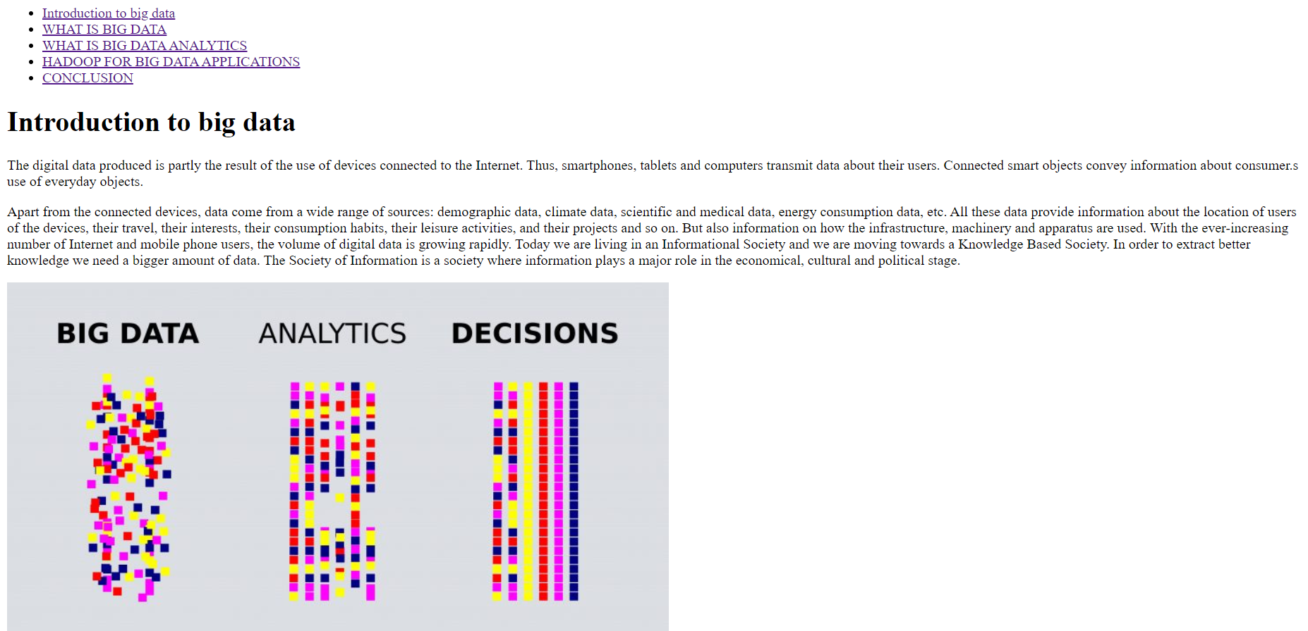

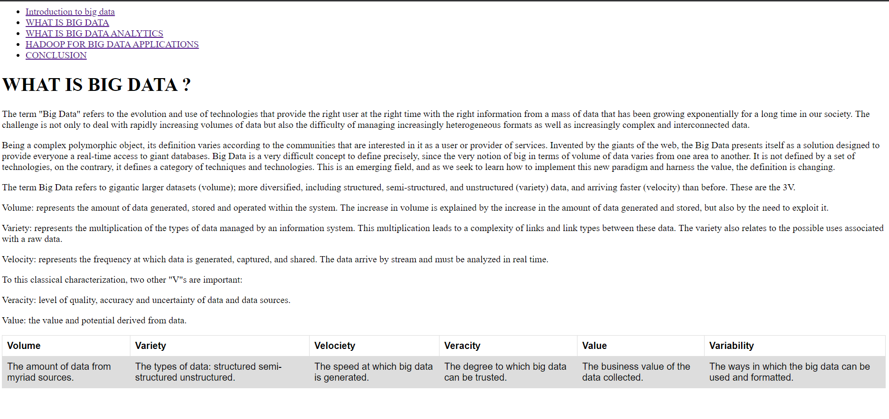

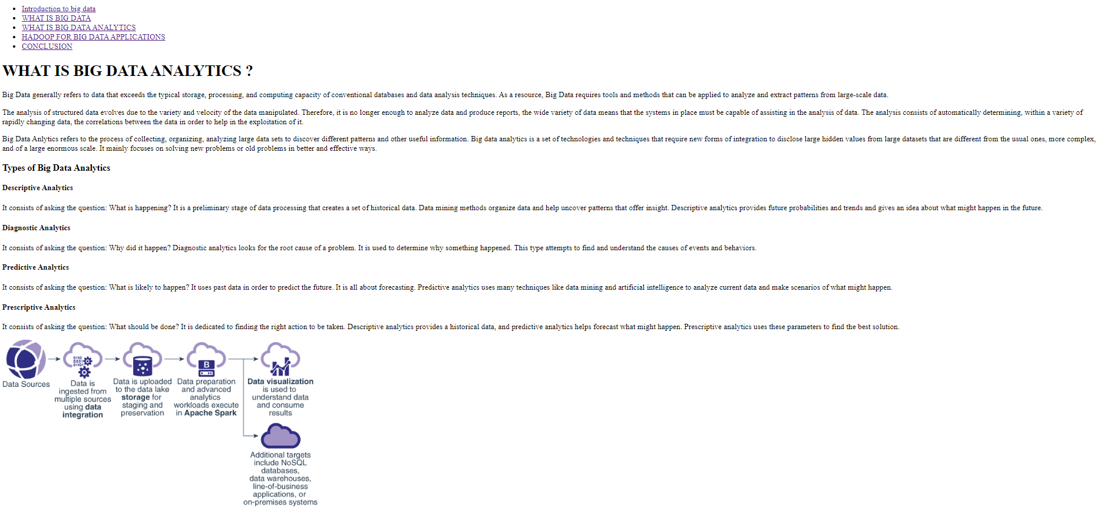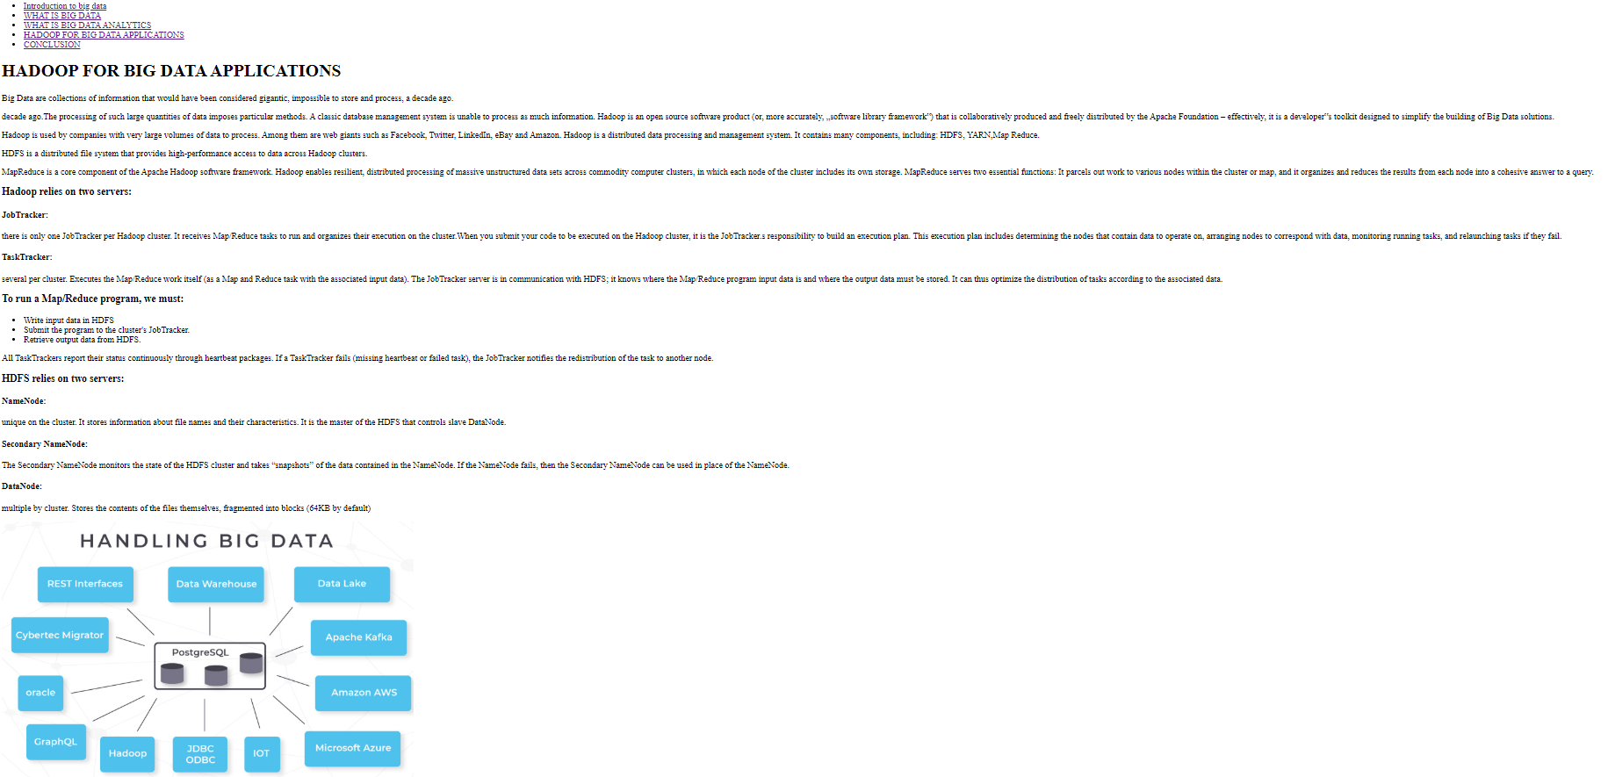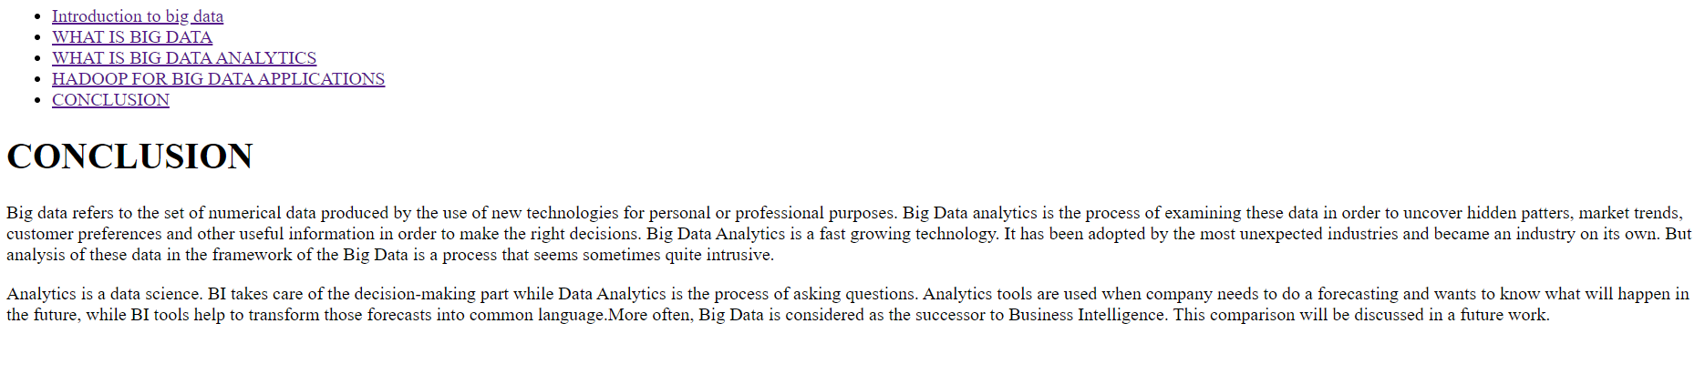

**Source code**

